**Computer Vision Project Proposal

**Date:** March 21, 2021

**Authors**: Yossi Gavriel, Ofir Nesher

**Title: Parking Space Detection with Python & OpenCV**

**Introduction**:

Two young Tel-Avivians, desperate from looking for parking in the city, trying to solve the 11th plague of Egypt.

Inspired by the "Ahuzot Hahof" parking lot at HaBima Square - we aim to implement a smart parking lot system that counts the number of cars inside and detects free parking space in the lot using elements and algorithms from the Computer Vision realm and topics learned in the course this last semester.

**Goals**:

The project will focus on Computer Vision methods learned in the lectures to detect empty parking spots in an image/video of a parking lot (given as inputs), and marking when these are becoming available or occupied.

Also, we implement a feature (section 3 in “Approach” below) for being able to count how many cars go in/out of the lot and also draw contours around moving objects in a pre-defined area (around the gate for example).

The outputs will be the given video with all the markings on top of the frames.

* Footage needs to be still (CCTV, for example).

**Approach**:

We have a few approaches for implementing a thorough end-to-end smart parking lot system, each is a different feature:

1. The first feature is the ability to **detect and count how many cars go in/out of a parking lot** and draw contours around moving objects in a region of choice in the video.

This enables monitoring the capacity and also to extract more data like calculating the average time a car is parked in the lot.

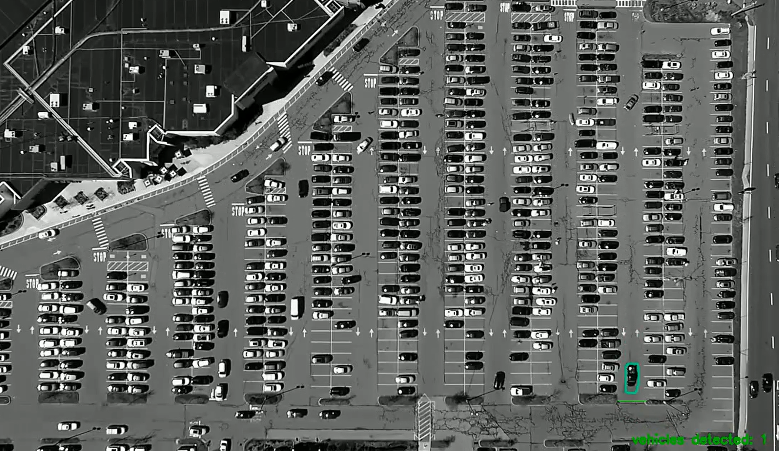

1. A “naive” approach for detecting free space - we manually mark empty spots (rectangles) in an image using the "Label Image" tool which created an XML file that contains the parking spot objects (the x, y, and the label) on the image of the empty parking lot we photoshopped.

Then, we monitor the drawn rectangles to see if the pixels within them were changed and therefore concluding that the spot is occupied/freed again.

This approach is partially implemented in some CV tutorials and we implemented this approach from scratch as an independent project and improved it.

We also made the algorithm more robust and more accurate overall, using various metrics for deciding if the spot is occupied or free, such as histogram comparison (learned in class), correlations between spots, and sequence matching.

According to these metrics, we learn and classify if a spot is empty/occupied.

The photoshopped empty image after we marked all spots manually:

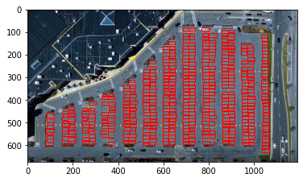

The output of the classification on the video:

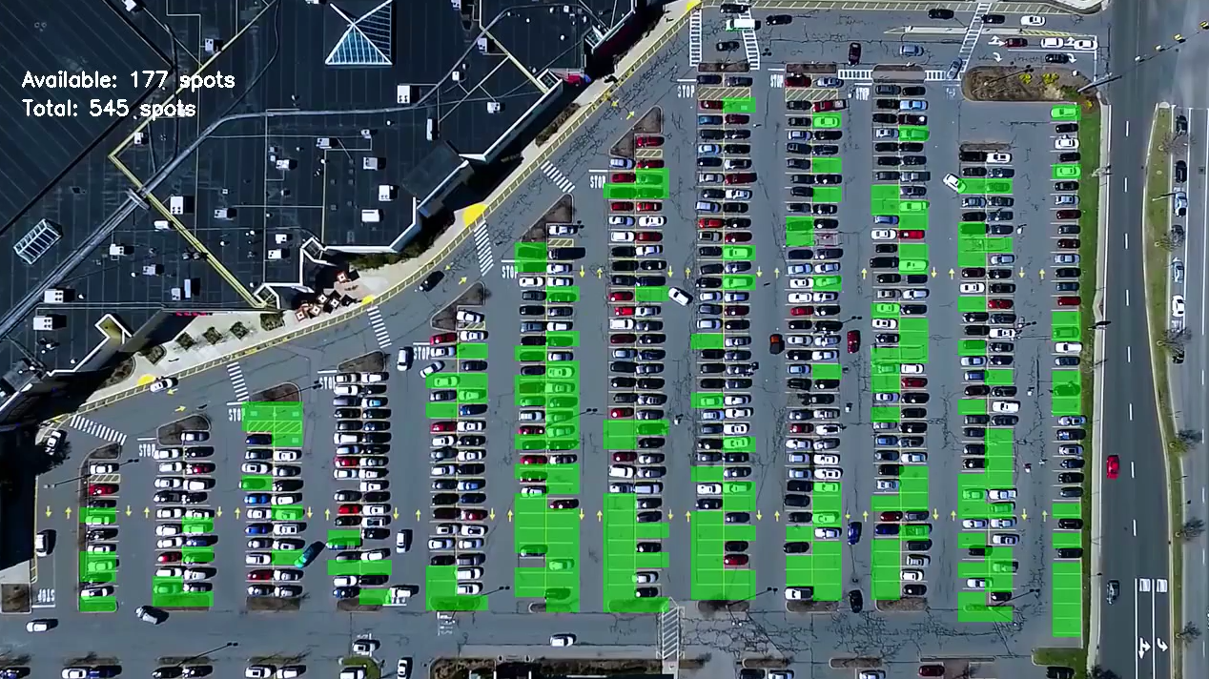

1. Similar to the above approach where each spot is compared to its own location in the empty lot’s image, we also implemented the same scenario where all parking spots are compared to a single “basic” example of a parking spot. This gives another flavor to our implementation.
2. Another small adjustment to detecting the parking spots on the empty lot’s image was using code and not manually.

We used the Canny Edge Detection algorithm, removed noise, and then used the Hough Line Transform method for detecting straight lines. After processing the results a little more we came up with this (which is a little more structured):

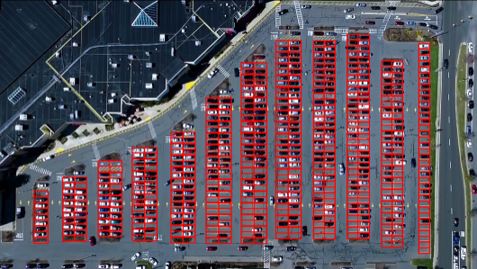

1. We also count the number of empty/occupied spots and analyze the results using the accuracy, precision, recall, and f1 scores.

After sorting the results by each metric we can see that “var_change_detection” comparison method got the highest results (99% accuracy) in the “median” approach and one of the faster methods:

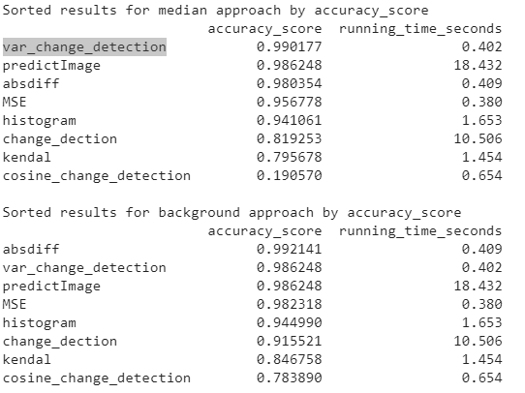

Visual results:

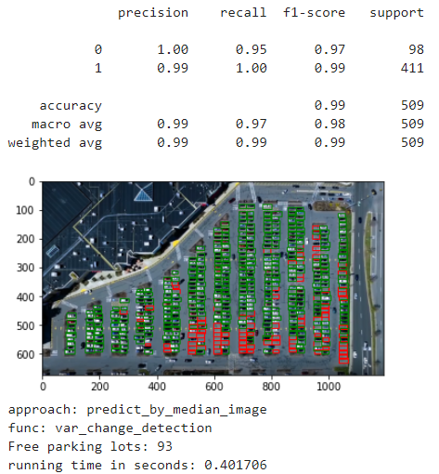

1. Using a **neural network**, we look at each parking spot that we marked (both manually as in section 2, and also using code, and in particular using Canny Edge Detection algorithm and Hough Line Transform method) and make a prediction of occupied or not.

This approach ended up working well:

The model learns what is an occupied and a free parking spot based on labeled images we extracted, such that during the video, it can classify if a spot’s status and if it changed between frames.

Examples of the training images:

 

1. Finally, the best part is to see it “in the real world” so we ran the model on our own footage we took with our drone:

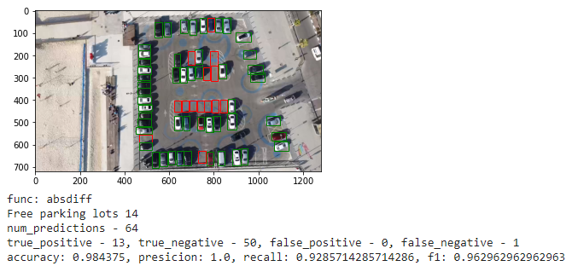

**Methods we learned in class and are used:**

* Image processing (noise removal for example)
* Change Detection
* Edge Detection
* Deep Learning
* etc.

**Summary of experimental results:**

* The accuracy of the neural network is pretty high and we’re happy with the final result.
* Playing around with the different metrics was fun and we got interesting data:

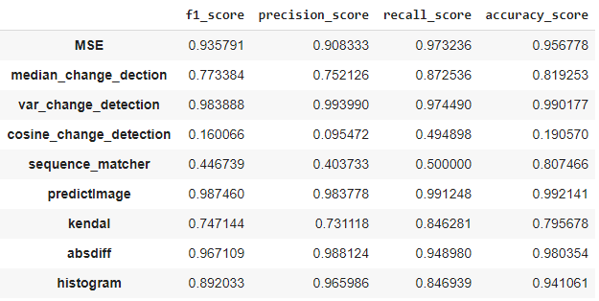

* The Deep Learning implementation gave us these numbers:

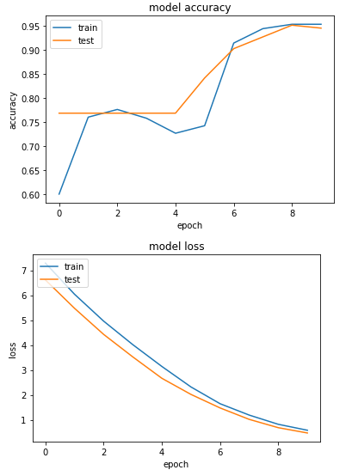

* The results on our drone footage are pretty good and we were excited to go out and test it, it gave it a more personal aspect.

**Future work (“What would you do if you had more time”):**

* It would be nice to have a model which is able to identify cars in an image where the view is from high above.

The popular [COCO dataset](https://cocodataset.org/#home) which is large-scale object detection, segmentation and captioning dataset trained on many images of objects and cars in particular did not help us because our input video’s view is too high up (although we started with it at the beginning).

* Furthermore, we would have liked to play around and try to run some of the code on the GPU, as we learned in class, but we didn’t have enough time to dig into it.
* We implemented some features in a few notebooks and we would like to combine all features in a single user-friendly online web-application such that a user would be able to upload a video and get the processed video back or to implement a system that sends an SMS anytime a spot is freed :)

**Resources**:

* CV/ML tutorials and GitHub repositories from around the web: [This paper (Image Handling and Processing for Efficient Parking Space Detection and Navigation Aid)](https://arxiv.org/ftp/arxiv/papers/1807/1807.02424.pdf),

[Deep Learning approach](https://towardsdatascience.com/find-where-to-park-in-real-time-using-opencv-and-tensorflow-4307a4c3da03), [Olga's naïve partial-implementation](https://github.com/olgarose/ParkingLot), [a report about the process we are trying to implement](https://easychair.org/publications/open/2STV)

(Just to name a few which we were inspired by and tuned)

* Our own code and lecture slides from the semester (from the Computer Vision course and the Deep Learning course homework assignments).